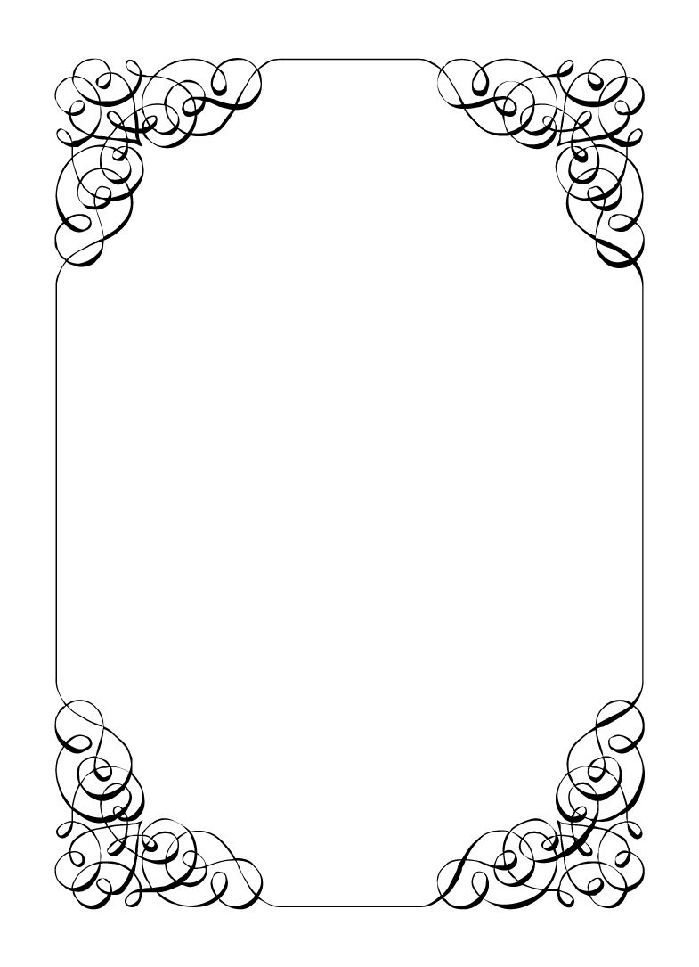

Not here to wed spiders

Lucky the Wonder Dog

*In the small town of Duck Rise, Victoria, Stralya live: BOGANS. Bogans are much like the regular folk, but drunker and louder. Some of them even fall in love. But before they settle down and poop out a mess of kids, they gotta have a wedding! Weddings are the best. Everyone gets proper plastered. Lots of kissing. Lots of drama. Fun times for all. Nothing ever goes wrong at a wedding...*  
*\*\*ominous thunder clack\*\**

Lucky the Wonder Dog

Dog *Loyal, Hungry, Possessive*

Cursed by a wizard, you roam the lands in search of your true form once again, you have the intelligence of a man but the form of a dog.  
You hope to one day reverse this curse, but its probably not happening soon. Plus this dog life is pretty good, no need to rush it.  
You got a job as a stunt dog on a TV show called WoWza and then left that to live with Sparkie.  
(You are a dog and like most dogs, you cannot speak English. No talking).  
  
Last night: It was the bachelor party. Chad, Dave, Wayne, Malibu, and Sparkie were there. The humans grabbed Chad from his bed, black bagged and took him on an 8 hour pub crawl. Each bar was great. Everyone gave you pats and treats made lots of noise! You also went to the casino, where you ate the most delicious trash. You ended up at a hotel and everyone went to their rooms and you slept on the floor in the hallway. Nobody looked good the next day.

**Goals**

* **Be the flowergirl:** You would look amazing, the star of the show!
* **Find out why Chad and Sparkie smell similar:** They must like playing together!
* **Find a new nicer owner:** Sparkie is a terrible owner, always bossing you around. If someone here is nicer, you should go home with them.
* **Be a good dog:** If anyone feeds you, make sure to help them out when you can.
* **Catch the bouquet:** Catch? That's my favourite!

**Other People**

**Chad Marolla**

Smells like dirt and Sparkie. Never has treats for you. Great pats though. Mostly just ignores you.

**Mercedes Bennie**

Smells like cigarettes. Never has treats for you. Never gives you pats. Smaller than the rest of the people for some reason.

**Robin Smith**

Smells like soap. Snuck you some of the wedding food as a treat. Bad pats, but they try. The way they walk and talk reminds you of your old owners.

**Dave Torana**

Smells like sex. Gives out good treats. Knows how to scratch behind the ears just right.

**Malibu Singer**

Smells like sweat and Corolla. Give you the BEST treats. No pats. You figure they are just trying to keep you out of way. Maybe if you help MORE, they will love you.

**Sparkie Castro**

Smells like dirt and Chad. Never has treats for you. Or pats. Sparkie is your owner after you lost track of your old ones.

**Abilities**

Use these to do things. They have a limited use, so check them off when you use them.

|  |  |
| --- | --- |
| Ability | Look what I found! |
| Talk to an Organiser and specify a player and an item. If the player has such an item, you will steal it from them. If the player doesn't, you will steal an item at random. |
| Usages: O O O O |

|  |  |
| --- | --- |
| Ability | Something smell fishy |
| Follow someone around for a minute. If you manage this, the player must show you their secret or their information: your choice. |
| Usages: O O O |

|  |  |
| --- | --- |
| Ability | Ooo I know this smell |
| Show an item to an organiser. They will tell you who started the game with this item. |
| Usages: O O O |

|  |  |
| --- | --- |
| Ability | Bury it! |
| Give an item to an Organiser. They will hold on to it for you. Ask them again if you wish to get it back. |
| Usages: Special |

|  |  |
| --- | --- |
| Ability | What's that boy? Charlie fell down a well? |
| You may never talk, only bark. However, as long as no one sees you, you may write notes and pass them to other players. |
| Usages: Special |

**Secret and Information**

Your Secret contains your guilty secret, while your Information contains one or more items of information you know. Both may be affected by abilities. Your lie may need to be filled out later.

While you can show your Secret and Information to whomever you like, you will probably not want to reveal your Secret too often. (Please note that you can’t solve the crime by looking at everyone’s Secret and Information – it’s not that easy!)

|  |  |
| --- | --- |
| Secret | You were a stunt dog from the famous TV show WoWza. |

|  |  |
| --- | --- |
| Information | Chad and Dave stayed in the same hotel room after the bucks. |

**The Organiser’s Word is Law:** The organisers are impartial. If you have a problem or want to do something unusual, see an organiser. The organiser’s power is absolute – and cannot be affected by ability cards!

**Winning and Losing:** You can achieve most of your goals simply by talking to people. The organisers will announce when the game is over. If you haven’t succeeded by that point – you’re too late! Be warned – not everyone here will want you to succeed!

**Doing Stuff:** Ordinary actions are resolved by simply carrying them out. If you want to try something unusual (such as trying to hack the pentagon), see an organiser. The organisers knows everything – and will be able to tell you the outcome of whatever it is that you are trying to do. (For example, you are trying to hack over state lines and you are caught.) Do use your imagination, though! – this is a very flexible game, and you can do all sorts of things beyond what’s listed in these rules.

**Fighting:** If an ability or item lets you hard another player, don’t just dive in! See the organisers first and tell them what you plan to do so they can oversee and give you more detailed rules if it’s necessary.

**Leaving:** You cannot leave, it is rude to leave a wedding and you are in the middle of nowhere!

**Role Cards:** If someone asks you for your role in the wedding ceremony, and you have one, you must show them all your roles.

**Item Cards:** Any items of importance within the game are represented as Item cards – and the only items that can affect the game are those detailed on the cards. If you do not have an Item card, you do not have that item with you.

**Time:** This game is played over three (ish) hours, including time for reading your character etc. There will be breaks throughout the evening! The organisers will tell you when each period starts and finishes.

**Character List**

**Chad Marolla – *Groom***

The soon to be husband. A bit nervous about the wedding, but is letting Corolla take care of the hard stuff.

**Corolla Castro – *Bride***

She knows what kind of wedding she wants, and that's the kind of wedding we are having! NO EXCEPTIONS!

**Gemini Belmont – *Maid of Honour***

She carries herself like she just escaped a warzone. Maybe she did? She's real quiet and might throat punch you if you ask stupid questions.

**Mercedes Bennie – *Flowergirl***

She's 12 but everyone knows better than to treat her like a 12 year old. Punk AF and will burn this all down on a whim.

**Robin Smith – *Priest***

Not from here. Better than everyone else (or at least thinks so).

**Dave Torana – *Best Man***

Childhood friends with the Groom. He was the smooth talking hottie that picked up enough for both of them. But that part of his life is over now.

**Malibu Singer – *Wedding Planner***

For a professional organiser, not very organised. Has just managed to keep everything running so far.

**Sparkie Castro – *Bride's Father***

He's been waiting his whole life for this moment. His baby girl is finally gonna get married and he knows just how to get through the day without crying...

**Vectra Marolla – *Groom's Mother***

The Queen that runs this town. Knows where the bodies are buried, but will never tell. Everyone respects her.

**Wayne Marolla – *Drunk Uncle***

He's maybe had a few too many. Started stumbling around and saying weird things. Every wedding has one.

**Lucky the Wonder Dog – *Dog***

A good dog. *bark* *bark* "What's that Lucky? You want pats?"

**Mungo Joint – *Photographer***

Seems like they are creeping on everyone, but they were hired to take wedding photos so it's probably fine.